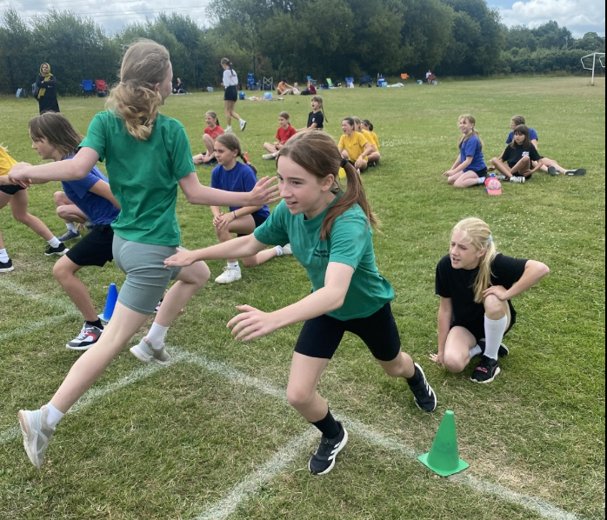
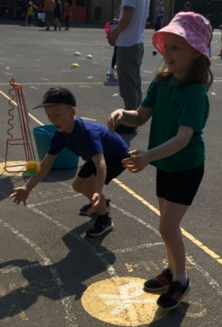
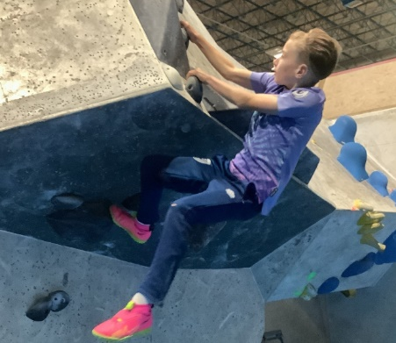
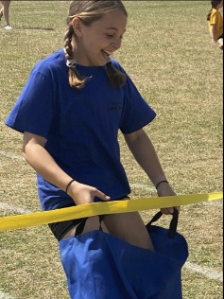
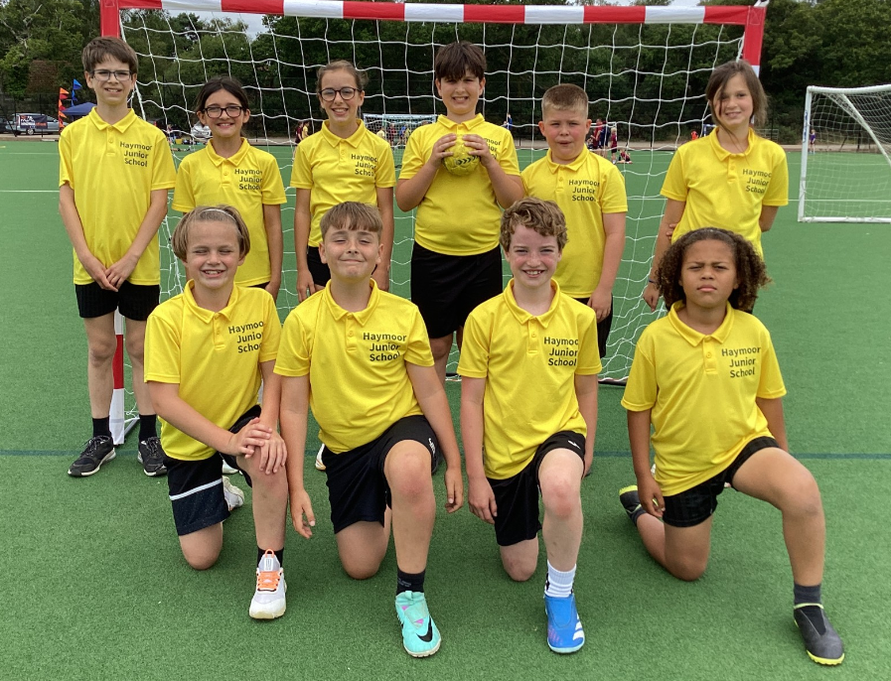
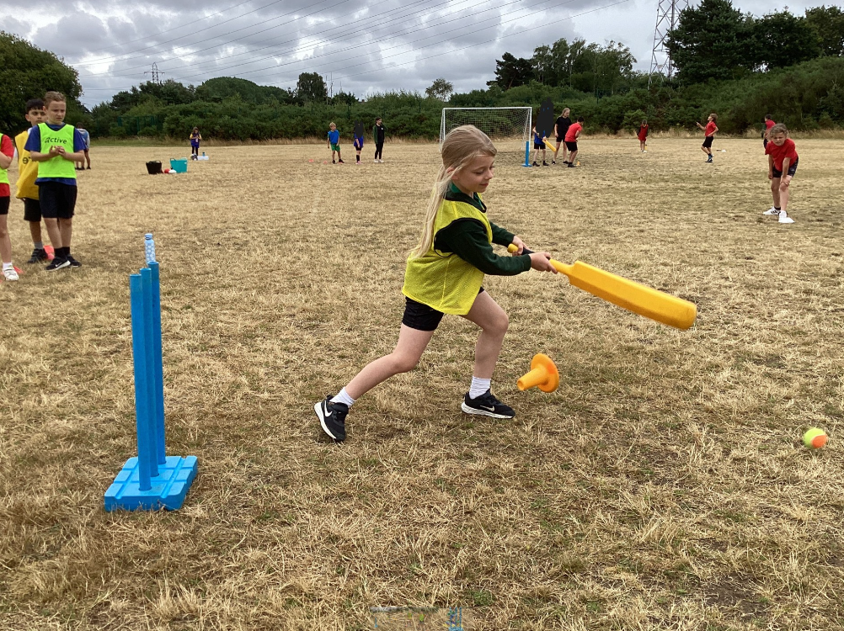
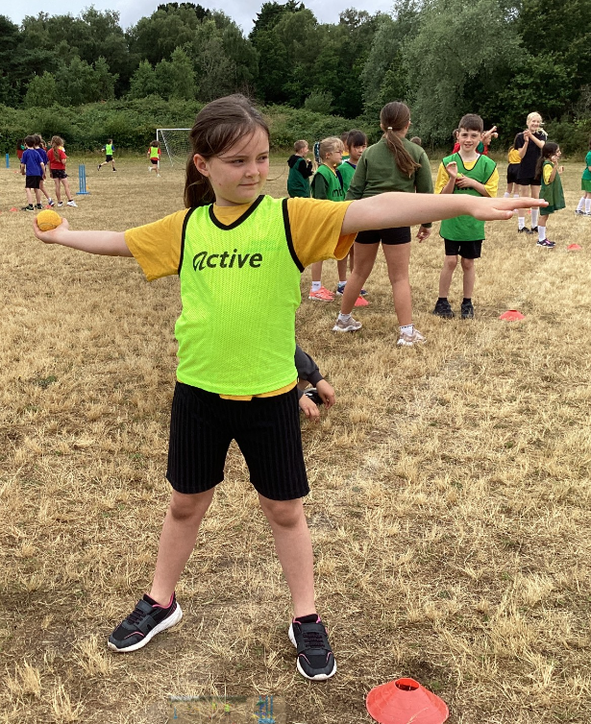
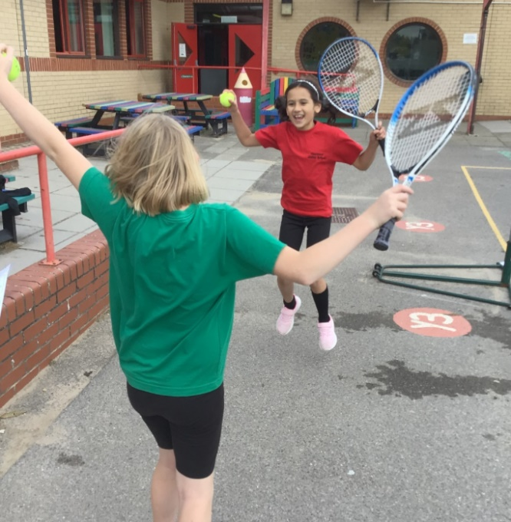
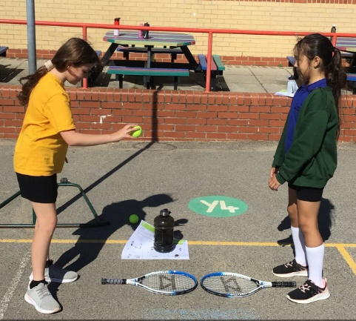
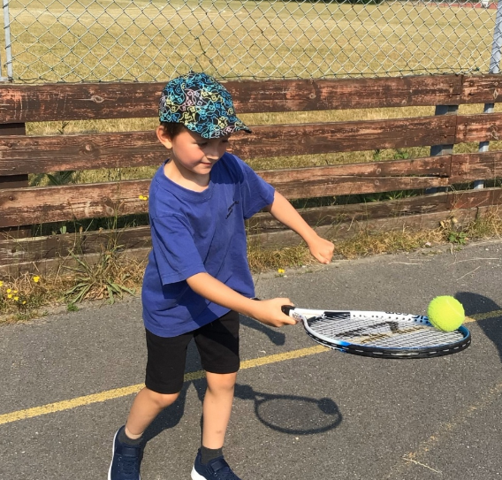
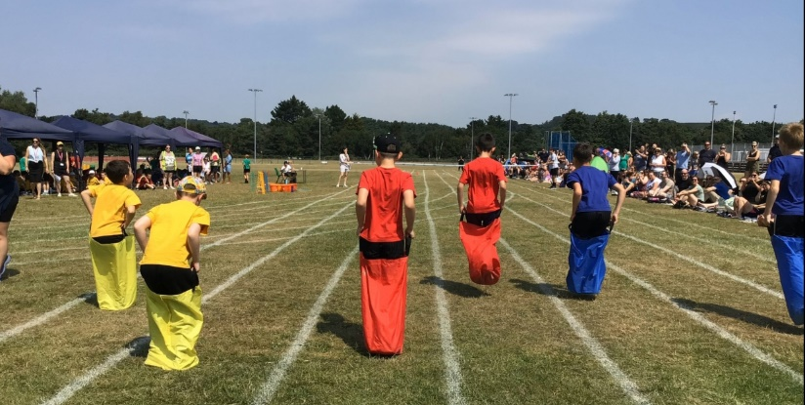
Haymoor Junior School
2023-2024


Details with regard to funding
Please complete the table below.

Swimming Data
Please report on your Swimming Data below.
Total amount carried over from 2022/23 | £00.00
Total amount allocated for 2023/24 | £19,610.00
Total amount allocated for 2023/24 | £00.00
Total amount of funding for 2023/24. To be spent and reported on by 31st July 2024. | £19,610.00

Meeting national curriculum requirements for swimming and water safety.

N.B. Complete this section to your best ability. For example you might have practised safe self-rescue techniques on dry land which you can then transfer to the pool when school swimming restarts.
Due to exceptional circumstances priority should be given to ensuring that pupils can perform safe self rescue even if they do not fully meet the first two requirements of the NC programme of study
What percentage of your current Year 6 cohort swim competently, confidently and proficiently over a distance of at least 25 metres?  N.B. Even though your pupils may swim in another year please report on their attainment on leaving primary school at the end of the summer term 2023.  Please see note above | 88%
What percentage of your current Year 6 cohort use a range of strokes effectively [for example, front crawl, backstroke and breaststroke]?  Please see note above | 82%
What percentage of your current Year 6 cohort perform safe self-rescue in different water-based situations? | 92%
Schools can choose to use the Primary PE and sport premium to provide additional provision for swimming but this must be for activity over and above the national curriculum requirements. Have you used it in this way? | Yes

Action Plan and Budget Tracking
Capture your intended annual spend against the 5 key indicators. Clarify the success criteria and evidence of impact that you intend to measure to evaluate for pupils today and for the future.

Academic Year: 2023/24 | Total fund allocated: | Date Updated:
Key indicator 1: The engagement of all pupils in regular physical activity – Chief Medical Officers guidelines recommend that primary school pupils undertake at least 30 minutes of physical activity a day in school |  |  |  | Percentage of total allocation:
 |  |  |  | 14%
Intent | Implementation |  | Impact
Your school focus should be clear what you want the pupils to know and be able to do and about  what they need to learn and to  consolidate through practice: | Make sure your actions to achieve are linked to your intentions: | Funding allocated: | Evidence of impact: what do pupils now know and what can they now do? What has changed? | Sustainability and suggested next steps:
To introduce a wider variety of playground equipment to encourage greater physical activity.  To maintain the variety of opportunities for physical activity – For pupils to experience equipment designed to develop different aspects of fitness.  To increase the % of children that believe that they take part in 30 mins of Moderate to Vigorous exercise. The 2023 Active survey stated that 41% of all pupils believe that they achieve this.  To continue swimming provision for those groups that missed their sessions due to Covid-19 restrictions. To increase the number of pupils able to achieve the minimum of 25m/self-rescue. | Sports Leaders to be involved in selection of equipment and its use at lunchtimes. A rota for this to be established.  Personal activity challenges set each week by the Sports Leaders.  New cohorts to be inducted on safe use and refresher sessions for all classes.  A rota of use for both the Play Trail/Traverse Wall and the outdoor Gym put in place and activity plans shared with all staff.  New staff to be inducted on the equipment in order for them to use with their classes. Refresher session for all staff  Introduce Moki competition between classes.  This allocation of funding has helped close the gap created by pool closures, but the impact of the lack of pool time is still evident in the higher percentage of non-swimmers,  throughout the school. | £675.72  £98.19  £309.25  £1,681.25  Total  £2,764.41 | Sports leaders have maintained ownership of the weekly challenges and developed a bank of ideas for the following year.  This ensures safe and full use of the equipment.  The watches are a great motivator for activity levels.  The focus has been on the current year 6 cohort, as this group were impacted by pool closures during lockdown. These sessions have enabled us to work with a target group. Now 92% of children can self-rescue, (up by 20% on last year). | Formalise/create a ‘book’ of these activities for future years.  Work alongside other schools in the Trust to share ideas and resources.  Maintain this good practice.  To formalize these results Weekly results announced in celebration assembly .  Follow this targeted approach, where all current non swimmers moving into year 6 will be assessed again and offered additional sessions where required.
Key indicator 2: The profile of PESSPA being raised across the school as a tool for whole school improvement |  |  |  | Percentage of total allocation:
 |  |  |  | 4%
Intent | Implementation |  | Impact
Your school focus should be clear what you want the pupils to know and be able to do and about  what they need to learn and to  consolidate through practice: | Make sure your actions to achieve are linked to your intentions: | Funding allocated: | Evidence of impact: what do pupils now know and what can they now do? What has changed? | Sustainability and suggested next steps:
Ensure all children’s sporting achievements are recognised.  Greater emphasis on Year group Festivals and Sports Day.  Continued use of celebration assemblies to reward sporting achievements.  Display and share achievements.  Continue this and develop methods of sharing with the wider community to celebrate success.  To support transitions through PE and sports afternoons  Smoother transition between year 2 to year 3 for mental well-being.  Increase staff involvement in physical activity, to impact pupil perception | Greater number of Bronze Ambassadors trained within school.  Year 6 pupils supporting festivals, afterschool clubs and year 5 pupils supporting transition events.  Maintain the celebration of all sporting achievements.  All staff to receive CPD training on delivering lessons that focus on teambuilding/trust/Perseverance/  problem solving.  To keep notice boards up to date  Offer half term/short courses of intervention for pupils identified by teachers – ‘Change For Life’  Use celebration assemblies to report on sporting achievements, both individual and team.  Medals and certificates to reward and raise the profile of PESSPA.  Focus on different aspects of PE lessons eg. Perseverance/  Staff asked to nominate one pupil each week, giving the reason behind the award.  Achieved through the Lunchtime Clubs supported by staff and by identified staff taking on responsibility for teams. | £529.40  £24.90  £280.23  Total  £834.53 | The success of the lunchtime rotas and activity challenges is evident in the interaction between the year groups and the desire of the children to take part. Sports Leaders address the whole school on a weekly basis, and have become important role models.  Feedback from these sessions was very positive and has become a timetabled part of PE planning for each term.  Greater number of children sharing their achievements.  Targeted intervention has been used to support smaller groups in PE allowing for a more personalized approach.  AFC Bournemouth delivered six sessions to encourage a greater number of girls to join in football.  This resulted in an increase in both lunchtime and afterschool participation.  This was completed by some year groups and announced in year group assemblies.  Increase in numbers of children signing up to lunchtime clubs. | Continue to promote the role of Sports Leaders, allocating time for both general training and specific training for events/festivals within school.  Make more regular references in year group assemblies, with the addition of Sports Journalists reporting.  Continue to share planning for whole Trust CPD.  To maintain this more targeted intervention.  To build on this good practice and involve other sports/outside clubs/coaches.  To establish this recognition across the whole school.  Development of core group of staff that support clubs/fixtures

Key indicator 3: Increased confidence, knowledge and skills of all staff in teaching PE and sport |  |  |  | Percentage of total allocation:
 |  |  |  | 32%
Intent | Implementation |  | Impact
Your school focus should be clear | Make sure your actions to | Funding | Evidence of impact: what do | Sustainability and suggested
what you want the pupils to know | achieve are linked to your | allocated: | pupils now know and what | next steps:
and be able to do and about | intentions: |  | can they now do? What has
what they need to learn and to |  |  | changed?
consolidate through practice:
Staff to develop their knowledge in delivering high quality PE.  PE specialist to continue to audit CPD needs and the impact of measures put in place.  Continuation of links with local providers.  Continue to subscribe to selected online resources – Getset4PE – to support delivery of PESSPA  Time to support staff with these resource  Membership of AfPE | Ongoing recruiting of outside agencies to offer a wide range of activities and CPD: Handball, Tag Rugby and Cricket.  Utilize PE specialist for continued CPD  Staff are ‘signposted’ to this resource | £920.00  £5,000.00  £262.00  Total  £6,182.00 | Strong links made with: Rugby, Handball, Athletics and Dodgeball and cricket. Staff have taken onboard ideas shared in these CPD sessions. There continues to be an increase of staff offering sports club at lunchtime. | To build on links made and continue to support staff in any area identified through a staff audit.
Key indicator 4: Broader experience of a range of sports and activities offered to all pupils |  |  |  | Percentage of total allocation:
 |  |  |  | 42%
Intent | Implementation |  | Impact
Your school focus should be clear | Make sure your actions to | Funding | Evidence of impact: what do | Sustainability and suggested
what you want the pupils to know | achieve are linked to your | allocated: | pupils now know and what | next steps:
and be able to do and about | intentions: |  | can they now do? What has
what they need to learn and to |  |  | changed?
consolidate through practice:
Investment in a wider variety of equipment for both lunchtime, afterschool clubs and curriculum activities to develop different physical skills.  Club Fair Programme to continue to offer breadth of opportunity for children being physically active.  Bikeability offer for all pupils in year 6, to support the Active Travel initiative. To give the pupils the confidence and skills to ride to school  Support Year 6 Residential, to enable participation in a wider variety of OAA  Offer a greater range of sporting opportunities for children to participate in.  Support the Year 5 Hook Day Activity to enable all pupils to participate in the climbing/parkour session. | Variety of lunchtime equipment purchased.  Replace equipment that is no longer fit for purpose, but is needed to continue delivery of curriculum activities.  Extra-curricular support to enable activities to continue throughout the year.  Year 6 HOY and EVC to coordinate  Coaches from local clubs to deliver taster sessions which have not been experienced before and/or provide an active club link.  To take all year 5 pupils to the local climbing centre, where they receive an introduction to both activities-delivered by centre instructors. | £1,952.49  £1,319.97  £1,145.00  Free to Schools  £3,550.00  £300.00  Total  £8,267.46 | Pupils expressed their enjoyment of having a greater choice of clubs and activities.  This provided safe equipment to be used.  Termly, 30+ lunchtime clubs are offered alongside 9 after school clubs.  Increased numbers at the majority of these clubs.  Evidence of greater engagement from pupils who previously lacked confidence.  Opportunities to take part in new activities with new skills and challenges.  Positive feedback from children and staff about the quality and impact of the sessions. | Continue to monitor and maintain a variety of equipment and clubs on offer.  Continue to book and offer a Summer Term course if required  Continue to support the OAA activities enabling access for all children.  Continue to support the Hook Day.

Key indicator 5: Increased participation in competitive sport |  |  |  | Percentage of total allocation:
 |  |  |  | 7%
Intent | Implementation |  | Impact
Your school focus should be clear | Make sure your actions to | Funding | Evidence of impact: what do | Sustainability and suggested
what you want the pupils to know | achieve are linked to your | allocated: | pupils now know and what | next steps:
and be able to do and about | intentions: |  | can they now do? What has
what they need to learn and to |  |  | changed?
consolidate through practice:
All pupils have an opportunity to engage in competitive activities – focus on disadvantaged pupils and those with SEND. These maybe as part of a team or set as individual challenges.  Replenish team kit/equipment.  Cover for staff to enable participation and development of festivals. | Attend PEDSSA/ Dorset FA competitions and enter events offered by our SGO – focus groups this year are PP and SEND  Purchase another set of football goals to enable the school to host both football and handball festivals. | £284.00  £769.99  £89.25  £28.73  £183.00  Total  £1354.37  Final Total Spent  £19,402.77 | All children participated in intra competitions in addition to Level 2 competitive festivals. This allowed all children to experience being part of a team. | Develop Festival offer in support of our SGO offer.

Haymoor Junior School attained the Gold School Sport Award for 2022-2023 in recognition of their continued commitment to high levels of involvement in competitions and festivals alongside a strong Young Leadership programme.

All pupils had the opportunity to take part in at least two intra competitions and one inter competition. We entered teams into both the boys and girls PEDSSA football leagues as well as fielding B and C teams in friendly festivals. We had individual success in the Cross-country events and notable achievements in the PEDSSA Athletics held at the Kings Park Stadium with Haymoor gaining medals in five different events. Pupils who attended the SEND Panathlon and Football reported back about how much fun they had had together with those that represented Haymoor at the Tag rugby Festival and Fliers Netball events.
Handball continues to grow in popularity, with a strong afterschool club as an extension to the curriculum input. Haymoor again qualified for the county final with the year 5 & 6 team.
As a result of our high participation levels at events, we were invited to attend the Dorset School Games ‘Play For Fun, Play For 60’, where pupils had the opportunity of playing Quidditch, Table Cricket, Orienteering and learning a Dance.
For a second year, Haymoor hosted the year 3&4 Poole School’s Tri-Golf Tournament with eight schools attending.
In school, our lunchtime clubs continue to be very popular with a record 32 being offered termly, thanks to the support of our staff. Afterschool clubs are also well attended and offer a broad choice of activities.

We have maintained our commitment to the Bikeability scheme with 12 students taking up the offer this year and all achieving Level 1 and 2.

Our Leadership programme continues to develop and as a team this year the Leaders devised weekly personal challenges to encourage physical activity at lunchtimes.
Links were maintained with community clubs with coaches delivering sessions in Tag Rugby, Handball and Cricket across year groups.

Two boys successfully trialed for the PEDSSA football team this year and two girls were selected at the county football trials. Five of our year 5 Handballers were successful at the County Handball Trials.

Signed off by
Head Teacher: | Lucy Waterhouse
Date: | 20/07/2024
Subject Leader: | Finola Hurlstone
Date: | 19/07/2024
CEO: | Kate Carter
Date:

