
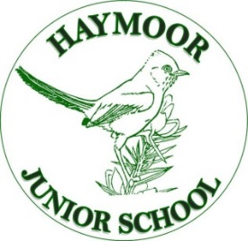
Article 28: Children have a right to a primary education.
Ad Astra Infant School
Sherborn Crescent
Poole
Dorset
BH17 8AP
Tel: 01202 602113
Email:office@adastra.poole.sch.uk
CEO / Executive Headteacher: Mrs Kate Carter BA (Hons) PGCE NPQH
Ad Astra Infant School Head of School: Miss Natalie Brown BA (Hons) PGCE SENDCo
Haymoor Junior School Head of School: Miss Lucy Waterhouse BA (Hons) PGCE
_{TEACH Trust Poole}
Trust Excellence Aspiration Collaboration Honesty

Haymoor Junior School
Ashdown Close
Poole
Dorset
BH17 8WG
Tel: 01202 659290
Email:office@haymoor.poole.sch.uk

Summer 2026
Haymoor Junior School instrument lesson application process
Dear Parents/Carers,
It is the time of year when we set up the instrumental lessons for September 2026. We currently have an amazing 430 children having lessons across the Trust!
The interest from the children for these lessons continues to be wonderful and I really hope that we can get lots of the children starting lessons in September. Please complete the simple application form on this link. The link will be open from the 2nd June to the 10th July 2026.
https://forms.office.com/e/eFNgzMwAJ4
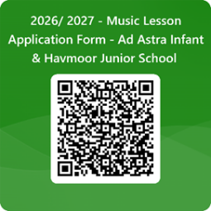
You will need to complete the application if you wish to start a new instrument and also if you wish to continue current lessons.
One form per child and one form per instrument.
Please could all applications be completed by the 10th July so that we can set up communications with the instrument teachers.
Children of families in receipt of Universal Credit may be entitled to receive financial assistance towards the cost of lessons for one instrument per year, pending further guidance to be provided by the Department for Education. In the meantime, please use the form to register your interest and indicate if participation would be dependent on financial assistance..
Please feel free to contact me on music@teachpoole.com if you have any queries.
Yours faithfully Mrs R Turner
Community and Music Performance Director

HJS music teachers

The music director, Mrs Turner, can be contacted on music@teachpoole.com for further information

Instrument | Teacher | Contact | Pricing  Based on 10 lessons a term
Ukulele | Andrew Marns | a.marns@btinternet.com | £65 for 10 shared lessons
Ukulele | Andrew Marns | a.marns@btinternet.com | £130 for 10 1-1 lessons
Guitar | Andrew Marns | a.marns@btinternet.com | £65 for 10 shared lessons
Guitar | Andrew Marns | a.marns@btinternet.com | £130 for 10 1-1 lessons
Drum kit |  | To be confirmed – please just record your interest on the online form
Piano/  Keyboard | Sue Lockyer | sueelockyer@icloud.com | 20 minutes in groups = £7 per session  20 minutes 1-1 = £13 a session
Singing | Julie Dales Bull | dalesbull@aol.com | £60 for 10 shared lessons  In groups of 4 or 5
Flute  Clarinet  Saxophone  TooTs  DooDs  (Cheaper woodwind alternative) £30 to buy | Julie Dales Bull | dalesbull@aol.com | £70 for 10 shared lessons
 | Julie Dales Bull | dalesbull@aol.com | £115 for 10 individual lessons
Violin  Cello | Charlotte Stopps | fingersandstrings@icloud.com | £70 for ten shared lessons
Violin  Cello | Charlotte Stopps | fingersandstrings@icloud.com | £150 for 10 individual lessons
Trumpet  Trombone  Cornet | John Bilby | johnbilby@outlook.com | £60 for 10 shared lessons
Trumpet  Trombone  Cornet | John Bilby | johnbilby@outlook.com | £120 for 10 individual lessons

Financial assistance can be applied for on the Soundstorm website

First Access - SoundStorm Music Education Agency (soundstorm-music.org.uk)

