

Haymoor Junior School

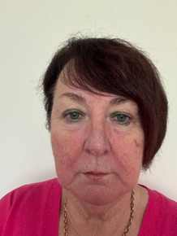

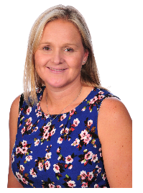
Child Protection & Safeguarding 2026-2027
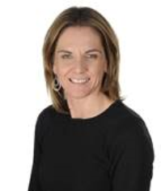
Designated Safeguarding Governor
Julie Jeans
Designated Safeguarding Lead:
Michelle Williamson
Deputy Designated Safeguarding Lead:
Lucy Waterhouse
Deputy Designated
Safeguarding Lead:
Kate Carter





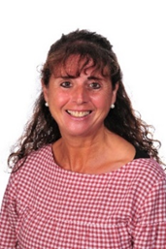
Designated
E-Safety Champion:
Dale Walters
Sam Brunton

Designated
Anti-bullying Champion:
Lauren Forryan

Home Academy Liaison Officer:

Lesley Specterman

Deputy Designated Safeguarding Lead:
Katie Killahena

BCP LADO:
Hayley Cowmeadow
Telephone: 01202 817 600
Email: LADO@bcpcouncil.gov.uk



