School Uniform Policy

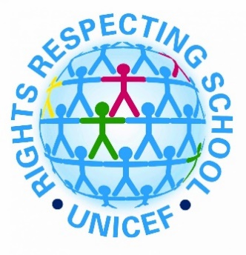
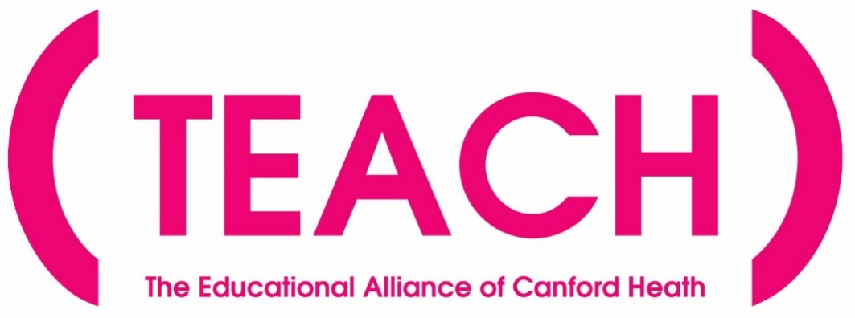

Statement of Intent
Our mission is to promote a love of learning in order to maximise the life chances of every child in our Trust. Through nurturing, high expectations and skilled teaching, we will have a lasting and positive impact on our local and wider community.

Our Vision
The TEACH Trust supports our children to become empowered citizens that make a meaningful contribution to society. Our curriculum reflects our locality and all it offers and aims to educate all children in matters which affect humanity in the wider world: these include all matters that relate to the climate and the world around us, such as climate change; the importance of respecting and celebrating the importance of equality and diversity; and being responsible global citizens.
We have the highest aspirations for our children: the broad and balanced curriculum promotes learning, provides cultural capital and supports spiritual, moral, social and cultural development. The Rights Respecting Gold awards and Anti Bullying awards reflect some of many ways in which education for character are integral to the work of our schools and highlights our focus on the children’s personal development.
We aim to inspire our children to be socially conscious individuals who make a difference to the world. All our children secure the key learning and skills they will need to become lifelong learners and gain employment. Our ultimate aim is to improve all our children’s life chances and prepare them to thrive in their future lives.
Under the Equality Act 2010 and the Public Sector Equality Act which came into force in April 2011, the Trust has due regard to the need to eliminate discrimination, advance equality of opportunity and foster good relations.

TEACH Trust School Uniform Policy

Our Trust, like the vast majority of schools, has a strict uniform policy where children are encouraged to take pride in their appearance and of the school. We are proud of the appearance of the children and feel that it is an important factor in school discipline and standards and helps support a sense of belonging. This also reduces tension between children, as they do not have to compete with their peers for the latest fashions, reducing peer pressure.

The well-being of our children is of utmost importance to us and their safety is paramount, and through wearing the correct uniform, it makes it easier to identify our children, especially outside of the school premises.

We are very aware that parent(s)/carer(s) may not be in a financial position to spend a great deal of money on school uniform, and this is why we have tried to ensure that the requirements of most of our school uniform allows parent(s)/carer(s) to buy ‘general’ uniform, like trousers, dresses and skirts, from good value shops, or supermarkets, for approximately £3 per item.

The requirements of our school uniform are detailed on the following pages:

General Uniform

Autumn to Easter Term

 | Ad Astra/Haymoor | CHIS/CHJS | Not Acceptable
Trousers | Grey, black or charcoal tailored  school trousers  School conventional material full length | Grey, black or charcoal tailored  school trousers  School conventional material full length | No jeans, corduroy, leggings, tight fitting, Lycra or skinny fashion trousers  (Please note: some shops do sell  ‘skinny’ trousers as part of their school uniform range, but they are not acceptable for these schools.)
Jumper or school sweatshirt or school cardigan | Bottle green with school logo | Purple with school logo | Other sweatshirts Hooded top  Fleece  Non regulation jumper/cardigan
Skirts | Grey, black or charcoal knee length skirts | Grey, black or charcoal knee length skirts | Fashion skirts, i.e. pencil or mini skirts  Stretchy or mini-skirts Skirts shorter than the knee
Pinafore | Grey, black or charcoal knee  length dress | Grey, black or charcoal knee  length dress | Dress shorter than the knee
Shorts | Black, grey or charcoal tailored  shorts or culottes | Black, grey or charcoal tailored shorts or culottes | Fashion shorts / lycra  Football shorts
Socks and tights | Plain grey, black or white socks  Plain grey, black or white opaque or knitted tights | Plain grey, black or white socks  Plain grey, black or white opaque or knitted tights | Fashion tights  Coloured or patterned socks or tights  Bare feet  Tights of less than 50 denier
Shoes | Traditional black and low heeled school shoes  Velcro, laces, buckle or slip on only | Traditional black and low heeled school shoes  Velcro, laces, buckle or slip on only | Trainers (even if black) Hi tops  High heels, sling backs or open toed sandals  Wedges  Boots  Logos

Infant School only:

 | Ad Astra | CHIS | Not Acceptable
Polo shirt | Plain white – no motif | Plain white – no motif | Shirt  Coloured polo shirt
Wellies | Early Years children  only | Early Years children only
Junior School Only:

 | Haymoor | CHJS | Not Acceptable
Shirt | Plain white short or long-sleeved school shirt with collar  Tucked in and buttoned up at the neck | Plain white short or long-sleeved school shirt with collar  Tucked in and buttoned up at the neck | Casual or fashion shirt Polo shirts
Tie | Green and gold striped tie clip on or tie | Purple and grey striped tie clip on or tie | No school tie

Summer Term Uniform
(following Easter holidays only)

 | Ad Astra/Haymoor | CHIS/CHJS | Not Acceptable
Summer dress | Green and white striped or checked dress – knee length | Lilac and white striped or checked dress – knee length
Jumper or school sweatshirt or school cardigan | Bottle green with logo | Purple with logo | Other sweatshirts Hooded top  Fleece  Non regulation jumper/cardigan
Shorts | Black, grey or charcoal tailored  shorts or culottes | Black, grey or charcoal tailored shorts or culottes | Fashion shorts / lycra  Football shorts
Shoes | Traditional black and low heeled school shoes  Velcro, laces, buckle or slip on only | Traditional black and low heeled school shoes  Velcro, laces, buckle or slip on only | Trainers (even if black) Hi tops  High heels, sling backs or open toed sandals  Wedges  Boots  Logos

 | Ad Astra | Haymoor | CHIS | CHJS | Not Acceptable
Polo shirt | White | White - no tie required if wearing a polo shirt | White | White - no tie required if wearing a polo shirt | Coloured polo shirt
Short sleeved shirt/blouse | N/A | White.  If wearing the collared winter shirt, a tie MUST be worn | N/A | White.  If wearing the collared winter shirt, a tie MUST be worn

PE Kit

For all Teach Schools | Acceptable |  | Not Acceptable
Shorts | Black or white |  | Fashion sports wear  Leggings
Trainers | Non-marking  Supportive footwear  Lace or Velcro fastening |  | Plimsolls
Tracksuit trousers | Navy, black or grey – for use in cold weather |  | Brand names that dominate the  garment
P.E. bag | Drawstring
Infant School only

T-shirt | Plain white |  | Brand names
Junior School only
T-shirt | Coloured PE t-shirt (with school logo) in their house colour |  | Other coloured T-shirts  Brand names
Shin pads | For football or hockey
 | Haymoor | CHJS
Socks | White, black or green | White, black or purple
Swimming:

All children need to wear a swimming costume or swimming shorts (shorts may not be below the knee in length) and a swimming hat. Pupils can request changes to swimwear for personal or religious reasons. Children with a verruca need to wear a verruca sock or have a waterproof treatment covering.

 | Acceptable | Not Acceptable
Jewellery | Maximum of two small plain gold or silver stud-like ear-rings (one in each ear) Watches, but NOT Smart watches. | Not coloured or patterned earrings / hoops etc  Not permitted on a P.E. or swimming day  Covering piercings with plasters Smart Watches  No other accessories to be worn
Hair and make up | Conventional style and natural colour  Shoulder-length hair or longer to be tied up  Hairbands in school colours or muted colours | Inappropriate hairstyles i.e. brightly coloured, shaven and/or patterned styles  Inappropriate hairbands i.e. brightly coloured, big bows  Make-up, nail varnish, tattoo transfers. No make-up is permitted in school time
School bag  (Infant School only) | Bookbag with the school logo | Rucksacks

Please note: Whilst we understand that, as the school academic year comes to an end, your child may grow out of their school shoes, we still wish to maintain standards and the school uniform rules still applies. Please contact the Pastoral Care Team to discuss if you have any queries.

Obviously, the very large majority of pupils and parent(s)/carer(s) adhere to these high standards and support the schools in upholding them, for the good of their children and the positive reputations of the TEACH Trust schools. We are very grateful for this support and thank you for taking pride in your child’s appearance and their school.

Adhering to the TEACH Trust Uniform Policy

All pupils are expected to wear the appropriate uniform from home to school and home again, except when permission has been given because of school educational visits, or pre-arranged activity days, such as Comic Relief or non-uniform days. All pupils are representing the school at all times and should take pride in being part of their community.

If your child does attend school in uniform which does not conform to the agreed school policy, please note the following procedures will be followed:



3. A letter from the Head of School will be sent.
2. If issue is not resolved, the year leader will make a phone call to discuss the non-compliance of uniform policy.
1. Class teacher will make you aware there is an issue with non-compliance of uniform policy.
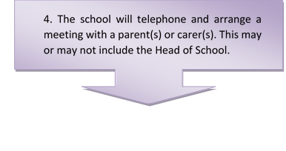

5. If, having met with the Head Teacher, there is still no improvement, the Head Teacher does have the legal right to send the child home until the correct uniform is worn. ** Any extended absences due to this will be recorded as unauthorised absence.

** Obviously, as a ‘primary school’ we do not wish to exercise this right, and feel that the steps shown above give parent(s)/carer(s) plenty of opportunity to rectify any breaches of school uniform. However, it is essential that ALL parent(s)/carer(s) and pupils take a shared responsibility for the reputation and appearance of the schools and their pupils.

The Department for Education Guidance on School Uniform updated 2021 states that ‘Teachers can discipline pupils for breaching the school’s rules on appearance or uniform. This should be carried out in accordance with the school’s published behaviour policy.’

Support for Families with School Uniform

In agreeing our school uniform, Trustees have been careful to minimise the amount of uniform which must be purchased from specialist suppliers, in order to follow the statutory guidance form the Department for Education on the Cost of School Uniform (https://www.gov.uk/government/publications/cost-of-school-uniforms/cost-of-school-uniforms ) and keep costs down.

All uniform items, apart from the school jumper/cardigan (and PE shirts at our junior schools), are generic and can be purchased from cheaper suppliers, such as supermarkets and value clothing stores. Having researched these items, we are aware that skirts and trousers, for example, can be bought for as little as £3 per pair. (We do ask that you take care NOT to buy clingy or tighter school trousers for girls from these uniform ranges, however, as they are most unflattering and entirely inappropriate for primary school aged pupils.)

The choice of school shoes has also been left intentionally broad, so that they may be purchased from a variety of outlets – however, the stipulation of NO TRAINERS is non-negotiable. (Black smart school shoes can be bought, for example, for as little as £8 and upwards from local supermarkets.)

We do appreciate that some families may struggle with replacing uniform as it is outgrown, so please do talk to us if you have concerns. We may be able to help.

Our Trust also provides a second hand school uniform shop from each school office available to all parents and carers, to help keep costs as low as possible.

If you are experiencing financial difficulties, then please do come and talk to the Pastoral Care Team, as we may be able to offer you support.

Uniform Policy
Equality Impact Assessment
Question | Response
Which relevant groups and  stakeholders have been consulted with in relation to this policy? |  | Please tick
 | Pupils | √
 | Trustees | √
 | Staff | √
 | Parents/Carers | √
 | Local Authority
 | Trade Unions
 | Other Advisors (give details) | √ (DfE)
What are the arrangements for  monitoring and reviewing the actual  impact of the policy? | Termly
 | Annually | √
 | When applied | √
 | If legislation changes | √
 | If a formal complaint | √

Does the policy affect one group less or more favourably than another on the basis of: | Y/N
Disability | N
Gender reassignment | N
Marriage or civil partnership | N
Pregnancy and maternity | N
Race | N
Religion or belief | N
Sexual orientation | N
Sex (gender) | N
Age | N
SEN | N
Vulnerable | N
Traveller, migrant, refugees and people seeking asylum | N
EAL | N

 | Y/N | Comments/Actions
Is there any evidence that some groups are affected differently? | N
If you have identified potential discrimination, are any exceptions valid, legal and/or justifiable? | N
Is the impact of the policy likely to be negative? | N
If yes, can the impact be mitigated by taking different action? | N/A

