Risk Assessment title: School Dog (Haymoor Junior School)

Assessment by: Lucy Waterhouse / Jared Denton | Role: Headteacher / Trust Estates Manager | Date: 5/12/2022
Approved by: Cathryne Packham | Planned review date: February 2023 (or sooner) | Record of reviews:
Brief description of the task, activity or event (if site-specific please state the name of the school):
To have a school dog on the Haymoor site

What is the hazard? | Who is at risk? | How might they be harmed? | Risks |  | Control measures currently in place | Current risk rating
What is the hazard? | Who is at risk? | How might they be harmed? | Likelihood | Severity | Control measures currently in place | Current risk rating
Dog biting or scratching a child | Students, school staff, visitors | A child is bitten by the school dog and the wound is severe enough to bleed | 2 | 3 | Staff to be with the school dog at all times. Children have it explained to them about approaching the school dog and understand not to frighten by making any movements that might be deemed threatening to the school dog.  The dog is selected for the affectionate nature and good temperament. The dog will be well trained and socialised.  Pupils/staff/visitors are advised not to put their face close to the dog.  Pupils/staff/visitors are only permitted to stroke the dog during allocated timeslots.  Only small groups of children (1:1 or 2:1 with an adult) will be able to visit the dog at a time.  Children are not to approach the school dog when she is in her crate as this is her private area  If the dog starts to get agitated, the adult will remove the dog from the room.  Dog will be formally trained at puppy training lessons and if needed, beyond this initial course. | Moderate
Minor injuries related to dog housing and equipment | Students, school staff, visitors |  | 1 | 2 | All dog bedding/housing is regularly checked for defects.  All dog equipment is stored in the head’s office out of the way when not in use.  The dog’s food and water bowls are kept out of the path of people to avoid any trips.  Any spillages from the dog’s bowl are wiped up immediately.  All dog bedding/housing is replaced regularly. | Low
Contamination from excrement or diseases or parasites such as fleas | Students, school staff, visitors | A child comes into contact with excrement and then touches their mouth or eats something. | 1 | 3 | All pupils/staff/visitors are advised to wash their hands thoroughly after touching the dog.  If the school dog is unwell Miss Waterhouse will not bring her into school and will seek veterinarian advice. Should the school dog become ill whilst at school, Miss Waterhouse will take her home immediately and seek veterinarian advice and the school dog supervising staff will ensure that any vomit or excrement is cleaned away and the area sanitised appropriately.  The school dog has regular visits to vet and has regular flea and worming treatments carried out by Miss Waterhouse.  A fenced off school area will be used for outside exercise and play. A bin will be provided for dog excrement only. Only adults will pick up excrement and it will never be left. Only grassed areas used for urination. | Low
People and children with allergies to dog hair or Asthma etc. | Students, school staff, visitors | A visitor to the school with extreme allergies to dog hair suffers a violent reaction as they are not aware that the school has a dog. | 2 | 3 | Notice in the school reception notifies visitors, parents and contractors that a dog is on site.  Parents notified well before arrival of the school dog that one would be a permanent member of the school and all medical records kept and checked of children who might have a reaction.  Cockapoo breed was chosen as it is lower risk for allergies.  All pupils and staff are advised not to touch their face after touching the dog.  All pupils/staff/visitors are advised to wash their hands thoroughly after touching the dog. | Moderate
People and children with a dog phobia | Students, school staff, visitors | A child with a dog phobia is confronted with the school dog and is upset and frightened. | 1 | 2 | Notice in the school reception notifies visitors, parents and contractors that a dog is on site.  Parents notified well before arrival of the school dog that one would be a permanent member of the school and parents asked to notify school of any children with a phobia or who is anxious.  Parents encouraged to share if their child has a dog phobia or is anxious so that we can take the necessary measures to keep the child away from the dog.  The dog is always on a lead and is under the control of an adult – the child will be able to keep a safe distance and a child will always have a choice if they interact with the dog, or not.  The dog has a crate that can be used if visitors who are not used to dogs enter the school or if there is a situation at school that means the school cannot look after the dog adequately.  During busy times, such as breaks and time between lessons when lots of pupils and staff will be coming past the dog, the dog will be kept in a safe and secure area away from the commotion. | Low

Additional control measures required to reduce risks (if none, please state ‘none’) | Implemented by whom | Implemented by when | Date action completed | Final (residual) risk rating
None – all identified on the RA |  |  |  | Overall risk – moderate (6)

Using the TEACH Risk Evaluation table below, the school considers the likelihood of risk as unlikely and the severity as moderate resulting in the overall managed risk level, with mitigations in place as moderate (6). As such, this risk assessment will be reviewed regularly.

TEACH Risk Evaluation Matrix
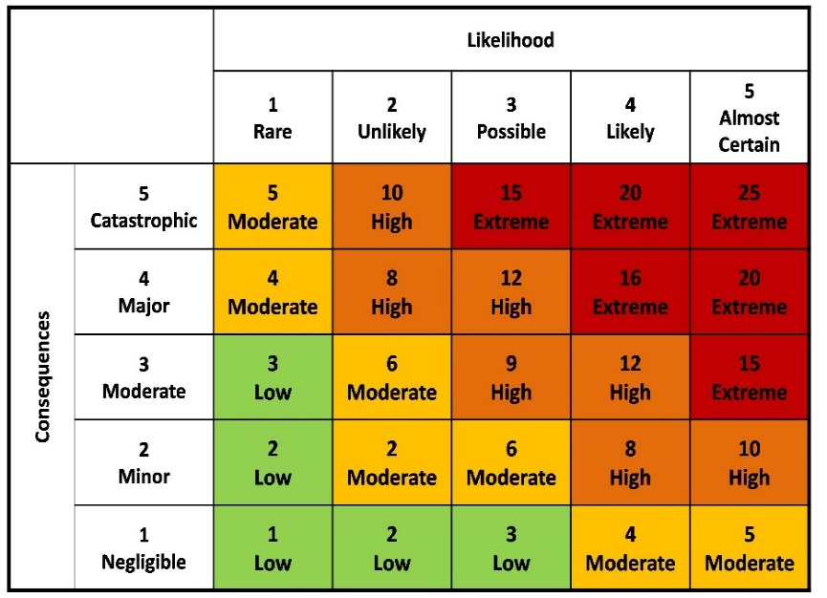
Severity

Risk evaluation ratings | Risk action required
Extreme risks (15-25): Possibility of fatality, disabling injury or occupational ill- health. | The task, activity or event must NOT take place. Seek H&S advice and guidance. If a dynamic risk assessment suggests extreme risks may be present, STOP immediately. Additional control measures are required to eliminate, reduce or control risks.
High risks (8-12): Possibility of a major injury requiring hospital treatment or an absence from work of 7+ days due to their accident-injury. | Aim to reduce risks before commencing the task. Seek H&S advice and guidance. Monitor to ensure control measures are fully implemented and maintained. Regularly review the risk assessment.
Moderate risks (2-6): Possibility of an injury requiring first-aid treatment and/or diagnostic tests in A&E (e.g. X-ray) | If possible, reduce risks further. Seek H&S advice and guidance. Monitor to ensure control measures are fully implemented and maintained. Regularly review the risk assessment.
Low risks (1-3) | No further action required. Monitor to ensure control measures are fully implemented and maintained. Regularly review the risk assessment.
TEACH Risk Action Table

